
President – Amanda Morris Cassady
Vice President – Amie Croshier
Director of Communications - Amanda Booker
Director of Fundraising - IIda Ramirez
Treasurers - Stefanie Trompeter Rolon
Secretary – Crystal Grobner
Program Coordinator – Kelly Hale-Obeso
Auditor - Jerica Freitas
Director of VMD - Kim Messina

LAKESIDE VOCAL MUSIC AND DANCE BOOSTER CLUB (LVMDB)
MINUTES – August 6, 2026
Ramirez Residence, Lakeside CA 92040

Attendees: Amanda Cassady, Kelly Hale-Obseo, Amie Croshier, Stafanie Trompeter-Rolon, Crystal Grobner, Ilda Ramirez, Amanda Booker
Guests: Director Kim Messina

I. Call to Order at 6:53pm.
II. Board or Voting Members and Guests Present.
III. Approval of Minutes - June 4, 2026 board meeting approved as presented.
IV. Treasurer’s Report filed as presented by Stefanie Trompeter-Rolon.
- US Bank ending cash balance $55,237.07.
- Motion: Amie Croshier moved to approve 2026-2027 Draft Budget with revisions:
- Increase expense line “Classroom Supplies & Improvements” from “Ending Cash Balance” by $400 to $1000.
- Remove expense line "Show Choir Trip Booster Chaperones" $4,800.
- Reduce "WCE Group (Group Fees)" by $5,000 from $10,000 to $5,000.
- Change the name of the "Encore" line item to "Act 1." Increase by $4,250 from $750 to $5,000.
- Increase "Bravo (Group Fees) by $1,800 from $3,200 to $5,000.
- Increase "Sponsorships" by $250 from $150 to $400.
- Increase "Musical Arrangements/Sheet Music by $1,250 from $750 to $2,000.
Amanda Booker seconded; motion carried unanimously.
V. Snap raise Fundraiser Recap.
VI. New Business.
- Review and Approval of Annual Budget.
- Motion: Ilda Ramirez moved to increase membership cost to $15 to cover pizza expenses effective Saturday, August 8th.
Kelly Hale-Obeso seconded; motion carried unanimously.
- Motion: Ilda Ramirez moved to increase dance and show choir show ticket prices to $7.
Kelly seconded; motion carried unanimously.
- Motion: Ilda Ramirez moved for the adoption of the individual fundraiser policy for Applebee’s.
Kelly Hale-Obeso seconded; motion carried unanimously.
- Tabled for next meeting: Booster to cover all choreography fees for choir and dance.
- Tabled for next meeting: pricing for board member chaperones.
- Discussed in the budget: Booster to cover directors lodging and associated fees for choir and dance.
- Discussed in the budget: Booster to cover super lines/large lines per comp.
- Booster to use Al’s Sports Shop for t-shirts this year.
- Motion: Crystal Grobner moved to remove bank signers Lindsy Morin and Cassandra (Cassie) Shumaker from the US Bank account.
Amanda Booker seconded; motion carried unanimously.
- Tabled for next meeting: policy for past due balances and the financial hardship form for families. Stefanie and Kim to reach out to families for past due balances from 25-26 school year.
VII. Bay Day - EB signed up.
VIII. Membership drive starts Saturday.
IX. Tabled for next meeting: Show Choir Trip.
X. Show Choir Merchandise - to be sold through MySchoolBucks and Al’s.
XI. Calendar of Events presentation.
Kelly Hale-Obeso to add days of the week to the calendar.
XII. Upcoming Board Member Meeting Dates 6:30-8:00pm:
August 6, 2026
September 3, 2026
October 8, 2026
November 5, 2026
December 3 ,2026 (off site/gift exchange)
January 7, 2027
February 4, 2027
March 4, 2027
April 1, 2027
May 6, 2027
June 3, 2027
XV. Booster VAPA representatives.
- Kelly Hale-Obeso is appointed Drama Representative with ____ as the alternate.
- Art and band/orchestra representatives will require representatives if programs wish to use the booster.
XVI. LED screen - awaiting architect.
XVII. Committee Reports.
- Fundraising Committee Report
  - Motion: Ilda Ramirez moves to approve the Fundraising Calendar.
Stefanie seconded; motion carried unanimously.
XVIII. Good of the order.
XIX. Announcements.
XX. Open Floor.
XXI. Adjournment at 9:50pm.

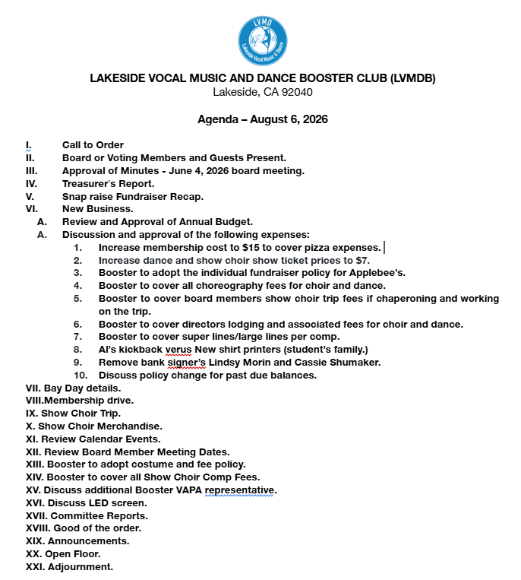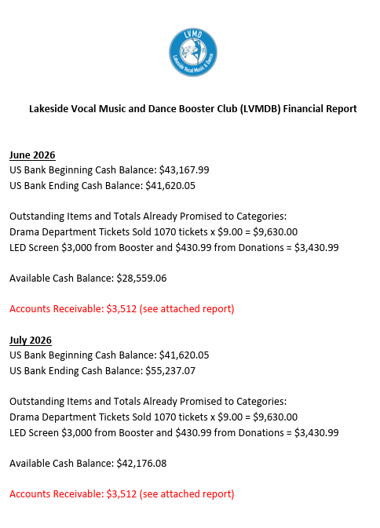
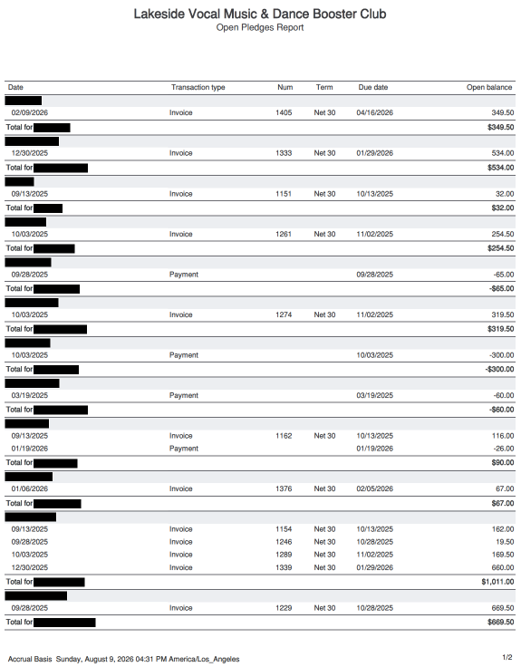
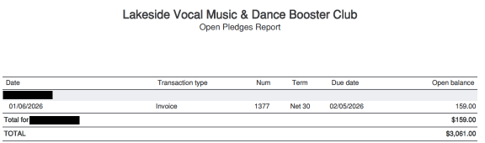
2026-27 Performance Dates
LMS Show Choir and Dance
***this is a live document and will continue to update***

August
🔵11(Tues) - Bronco Round Up new student orientation
🟡15(Sat) - Show Choir Bay Day Family Kick Off
🔵18(Tues) - First Day of School
🟣28(Fri) - Future Sultan night for LMS Dance and band @ Santana- optional

September
🟡8(Tues)- show choir parent meeting 6 pm
🟡🔵15(T) - Back to School Night - SHOW CHOIRS
🔵17 - 6th grade camp meeting 5pm
🔵22 - New York Trip Meeting 5pm

November
🔵23-27(M-F) Thanksgiving break - no school

December
🟡3(Th)- Winter choir concerts - SHOW CHOIR 4:30 & 6:30
🟡5(Sat)- spirit of Christmas. 3pm-7pm (exact time TBD). - Adrenaline and Harmonies
🔵12/19-1/3 Winter Break - no school

January
🟣13(Wed)- winter dance concerts beginning dance - DANCE
🟣14(Th) - winter dance concerts - ADVANCED AND INTERMEDIATE DANCE
🔵🟡🟣 TBD Future Bronco Night performances
🔵25-29(M-F) - 6th Grade Camp

February
🟡4(Th)- 9am-12:30pm CAL RTA performance n la Mesa - Aptitude
🟣7(Sun) - WCE REGIONAL DANCE COMPETITION - RBHS (INTERMEDIATE & ADV DANCE)
🟣13(Sat) - WCE REGIONAL DANCE COMPETITION - Carlsbad HS (INTERMEDIATE & ADV DANCE)
🟡19-20(Fri-Sat) - Chaparral show choir competition - Friday evening - BOTH SHOW CHOIRS

March
🟣5-7(Fri-Sun) - WCE Nationals Long Beach - ADVANCED DANCE
🟡10(Wed) - Dessert Concert
🟣12-14(Fri-Sun) Dance Competition #1- ADVANCED DANCE and select Intermediate duos/trios
🔵🟡TBD Open House- show choir performs
🔵3/22-4/4 Spring Break - no school

April
🟡9-10(Fri-Sat) - Burroughs show choir competition
🟡15-19(Th-Mon) - Oceanside Sound Off show choir competition AND show choir trip - SHOW CHOIR
🟢26-30(M-F) - 7/8th grade drama tech week and shows

May
🟡5(Wed)- Spring choir concerts - SHOW CHOIR
🟣12(Wed) Spring Beginning dance concerts
🟣13(Th) Spring Advanced/Intermediate dance concerts
🟣20-23(Th-Sun) Dance Competition #2 - ADVANCED AND INTERMEDIATE DANCE
🟢24-27(M-Th) 6th grade drama tech week and performances

June
🟡🔵9(Wed)- Promotion performance - 8th grade show choir students

